Task 2: Exploratory Data Analysis (EDA)

Dataset: Titanic Dataset

Name: Omkar
Date: 20 September 2026

1. Objective
The objective of this task is to perform Exploratory Data Analysis (EDA) on the Titanic dataset and understand its structure, statistics, patterns, relationships, missing values, and outliers.

2. Dataset Overview
The Titanic dataset contains information about passengers, including their age, gender, passenger class, fare, and survival status.

3. Data Inspection
The dataset was inspected using functions such as head(), shape, columns, and info() to understand its structure and characteristics.
Screenshot: df.head() and df.info()

4. Descriptive Statistics
Descriptive statistics were calculated using the describe() function to understand the numerical variables, including their mean, minimum, maximum, and standard deviation.
Screenshot: df.describe()

5. Missing Value Analysis
Missing values were identified using the isnull().sum() function. Missing values were observed in some columns, particularly the Age column.
Screenshot: Missing values output

6. Duplicate Value Analysis
Duplicate rows were checked using the duplicated() function to identify repeated records in the dataset.
Screenshot: Duplicate value output

7. Data Visualization

7.1 Age Distribution
A histogram was created to visualize the distribution of passenger ages.
Screenshot: Age Distribution graph

7.2 Gender Distribution
A count plot was created to visualize the number of male and female passengers.
Screenshot: Male vs Female graph

7.3 Survival Distribution
A count plot was used to visualize the number of passengers who survived and did not survive.
Screenshot: Survival Count graph

7.4 Passenger Class Distribution
A count plot was created to show the distribution of passengers across different passenger classes.
Screenshot: Passenger Class graph

8. Relationship Analysis

8.1 Gender vs Survival
The relationship between passenger gender and survival status was visualized using a count plot.
Screenshot: Gender vs Survival graph

8.2 Passenger Class vs Survival
The relationship between passenger class and survival status was visualized using a count plot.
Screenshot: Class vs Survival graph

8.3 Age vs Fare
A scatter plot was used to visualize the relationship between passenger age and ticket fare.
Screenshot: Age vs Fare graph

9. Fare Distribution
A histogram was created to understand the distribution of ticket fares paid by passengers.
Screenshot: Fare Distribution graph

10. Outlier Analysis
Boxplots were used to identify possible outliers in numerical variables such as ticket fare.
Screenshot: Fare Boxplot

11. Correlation Analysis
A correlation matrix was calculated to understand the relationships between numerical variables.
Screenshot: Correlation matrix

12. Correlation Heatmap
A correlation heatmap was created to visually represent the relationships between numerical variables in the dataset.
Screenshot: Correlation Heatmap

13. Data Cleaning
Missing values in the Age column were handled using the median value of the column.

df_clean = df.copy()

df_clean["age"] = df_clean["age"].fillna(
df_clean["age"].median()
)

14. Final Findings
The Titanic dataset was successfully explored using various statistical and visualization techniques. The analysis identified missing values, examined duplicate records, visualized passenger characteristics, analyzed survival patterns, investigated relationships between variables, and identified possible outliers.

15. Conclusion
Exploratory Data Analysis helped us understand the Titanic dataset by examining its structure, descriptive statistics, missing values, distributions, relationships, correlations, and possible outliers. Various visualization techniques were used to identify patterns and understand the data more effectively.

import pandas as pd
import pandas as pd
import seaborn as sns
import matplotlib.pyplot as plt
import seaborn as sns

df = sns.load_dataset("titanic")
df.head()

 | survived | pclass | sex | age | sibsp | parch | fare | embarked | class | who | adult_male | deck | embark_town | alive | alone
0 | 0 | 3 | male | 22.0 | 1 | 0 | 7.2500 | S | Third | man | True | NaN | Southampton | no | False
1 | 1 | 1 | female | 38.0 | 1 | 0 | 71.2833 | C | First | woman | False | C | Cherbourg | yes | False
2 | 1 | 3 | female | 26.0 | 0 | 0 | 7.9250 | S | Third | woman | False | NaN | Southampton | yes | True
3 | 1 | 1 | female | 35.0 | 1 | 0 | 53.1000 | S | First | woman | False | C | Southampton | yes | False
4 | 0 | 3 | male | 35.0 | 0 | 0 | 8.0500 | S | Third | man | True | NaN | Southampton | no | True

df.tail()
 | survived | pclass | sex | age | sibsp | parch | fare | embarked | class | who | adult_male | deck | embark_town | alive | alone
886 | 0 | 2 | male | 27.0 | 0 | 0 | 13.00 | S | Second | man | True | NaN | Southampton | no | True
887 | 1 | 1 | female | 19.0 | 0 | 0 | 30.00 | S | First | woman | False | B | Southampton | yes | True
888 | 0 | 3 | female | NaN | 1 | 2 | 23.45 | S | Third | woman | False | NaN | Southampton | no | False
889 | 1 | 1 | male | 26.0 | 0 | 0 | 30.00 | C | First | man | True | C | Cherbourg | yes | True
890 | 0 | 3 | male | 32.0 | 0 | 0 | 7.75 | Q | Third | man | True | NaN | Queenstown | no | True

Df.shape
(891, 15)

Df.columns
Index(['survived', 'pclass', 'sex', 'age', 'sibsp', 'parch', 'fare',
'embarked', 'class', 'who', 'adult_male', 'deck', 'embark_town',
'alive', 'alone'],
dtype='object')

df.info()

<class 'pandas.core.frame.DataFrame'>
RangeIndex: 891 entries, 0 to 890
Data columns (total 15 columns):
# Column Non-Null Count Dtype
--- ------ -------------- -----
0 survived 891 non-null int64
1 pclass 891 non-null int64
2 sex 891 non-null object
3 age 714 non-null float64
4 sibsp 891 non-null int64
5 parch 891 non-null int64
6 fare 891 non-null float64
7 embarked 889 non-null object
8 class 891 non-null category
9 who 891 non-null object
10 adult_male 891 non-null bool
11 deck 203 non-null category
12 embark_town 889 non-null object
13 alive 891 non-null object
14 alone 891 non-null bool
dtypes: bool(2), category(2), float64(2), int64(4), object(5)
memory usage: 80.7+ KB

The dataset was inspected using the head(), shape, columns, and info() functions to understand the structure, size, column names, and data types.

df.describe()

survived | pclass | age | sibsp | parch | fare
count | 891.000000 | 891.000000 | 714.000000 | 891.000000 | 891.000000 | 891.000000
mean | 0.383838 | 2.308642 | 29.699118 | 0.523008 | 0.381594 | 32.204208
std | 0.486592 | 0.836071 | 14.526497 | 1.102743 | 0.806057 | 49.693429
min | 0.000000 | 1.000000 | 0.420000 | 0.000000 | 0.000000 | 0.000000
25% | 0.000000 | 2.000000 | 20.125000 | 0.000000 | 0.000000 | 7.910400
50% | 0.000000 | 3.000000 | 28.000000 | 0.000000 | 0.000000 | 14.454200
75% | 1.000000 | 3.000000 | 38.000000 | 1.000000 | 0.000000 | 31.000000
max | 1.000000 | 3.000000 | 80.000000 | 8.000000 | 6.000000 | 512.329200

Descriptive statistics were calculated to understand the numerical variables, including count, mean, minimum, maximum, and standard deviation.

df.isnull().sum()

0
survived | 0
pclass | 0
sex | 0
age | 177
sibsp | 0
parch | 0
fare | 0
embarked | 2
class | 0
who | 0
adult_male | 0
deck | 688
embark_town | 2
alive | 0
alone | 0
Missing values were checked using the isnull().sum() function.

dtype: int64

df.duplicated().sum()

Duplicate records were checked using the duplicated() function.

np.int64(107)

import matplotlib.pyplot as plt
plt.figure(figsize=(8,5))

sns.histplot(df["age"].dropna(), kde=True)

plt.title("Age Distribution")
plt.xlabel("Age")
plt.ylabel("Number of Passengers")

plt.show()

The count plot shows the relationship between passenger gender and survival status.

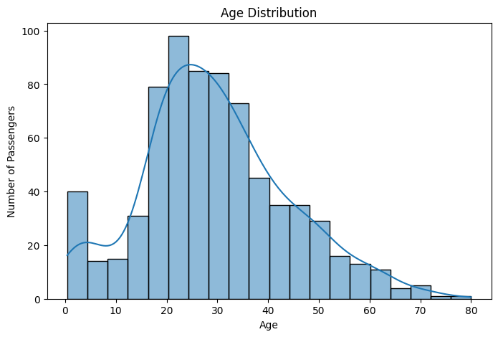
sns.countplot(data=df, x="sex")

plt.title("Male vs Female")
plt.show()
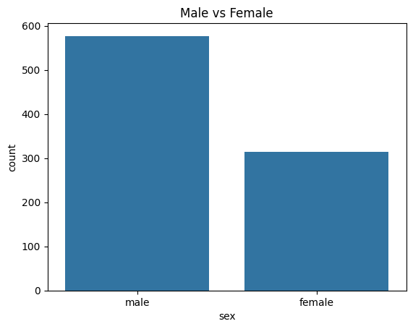
sns.countplot(data=df, x="survived")

plt.title("Survival Count")
plt.xlabel("Survived (0 = No, 1 = Yes)")

plt.show()
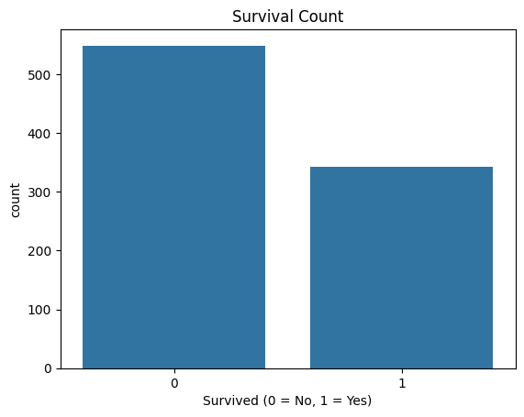
sns.countplot(data=df, x="sex", hue="survived")

plt.title("Survival by Gender")
plt.show()
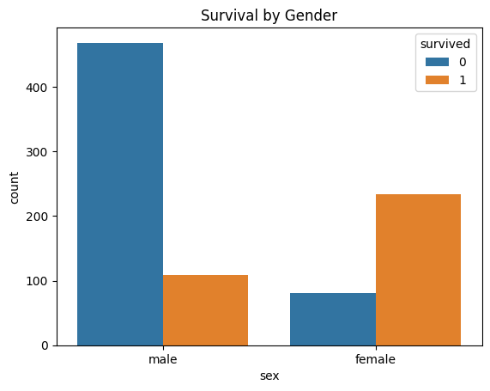
sns.countplot(data=df, x="pclass")

plt.title("Passenger Class")
plt.xlabel("Class")

plt.show()
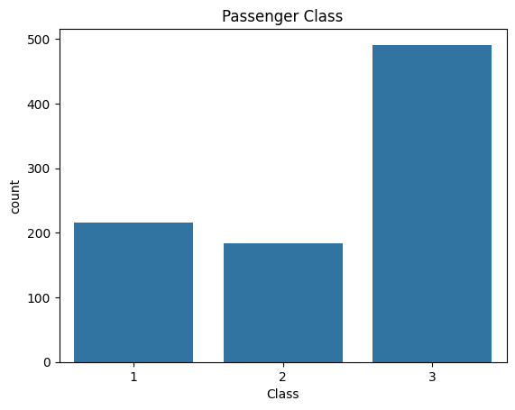

sns.countplot(data=df, x="pclass", hue="survived")

plt.title("Survival by Passenger Class")
plt.show()

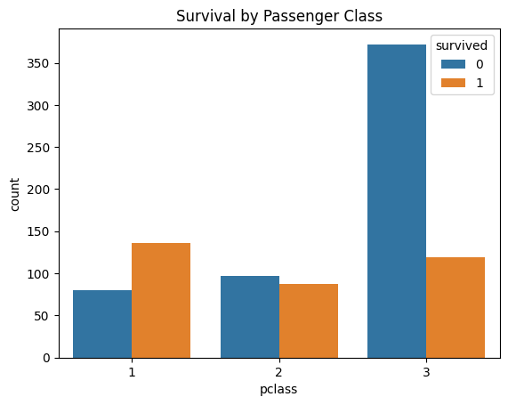

plt.figure(figsize=(8,5))

sns.histplot(df["fare"], kde=True)

plt.title("Ticket Fare Distribution")
plt.xlabel("Fare")

plt.show()
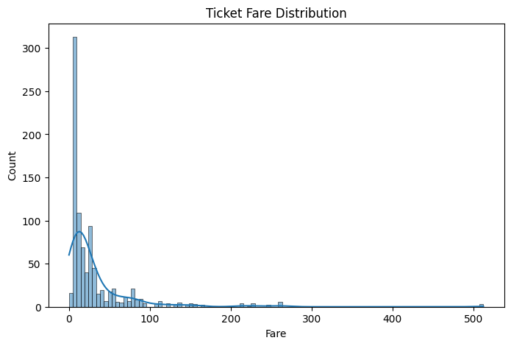
plt.figure(figsize=(8,5))

sns.boxplot(x=df["fare"])

plt.title("Fare Boxplot")

plt.show()
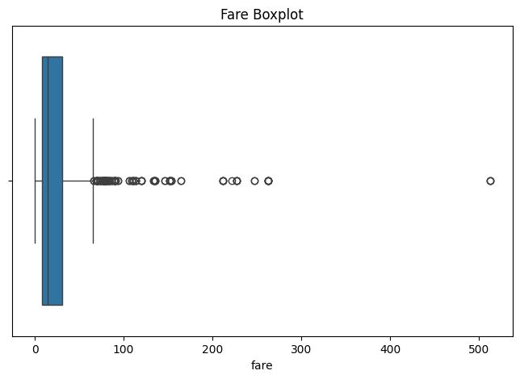
correlation = df.corr(numeric_only=True)

Correlation

survived | pclass | age | sibsp | parch | fare | adult_male | alone
survived | 1.000000 | -0.338481 | -0.077221 | -0.035322 | 0.081629 | 0.257307 | -0.557080 | -0.203367
pclass | -0.338481 | 1.000000 | -0.369226 | 0.083081 | 0.018443 | -0.549500 | 0.094035 | 0.135207
age | -0.077221 | -0.369226 | 1.000000 | -0.308247 | -0.189119 | 0.096067 | 0.280328 | 0.198270
sibsp | -0.035322 | 0.083081 | -0.308247 | 1.000000 | 0.414838 | 0.159651 | -0.253586 | -0.584471
parch | 0.081629 | 0.018443 | -0.189119 | 0.414838 | 1.000000 | 0.216225 | -0.349943 | -0.583398
fare | 0.257307 | -0.549500 | 0.096067 | 0.159651 | 0.216225 | 1.000000 | -0.182024 | -0.271832
adult_male | -0.557080 | 0.094035 | 0.280328 | -0.253586 | -0.349943 | -0.182024 | 1.000000 | 0.404744
alone | -0.203367 | 0.135207 | 0.198270 | -0.584471 | -0.583398 | -0.271832 | 0.404744 | 1.000000

plt.figure(figsize=(12,8))

sns.heatmap(
correlation,
annot=True,
cmap="coolwarm"
)

plt.title("Correlation Heatmap")

plt.show()
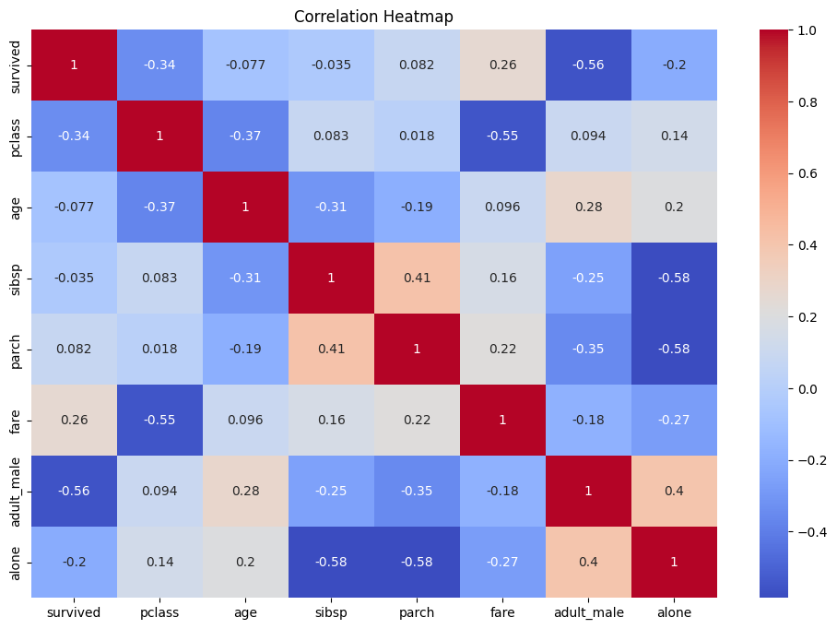
plt.figure(figsize=(8,5))

sns.scatterplot(
data=df,
x="age",
y="fare",
hue="survived"
)

plt.title("Age vs Fare")

plt.show()

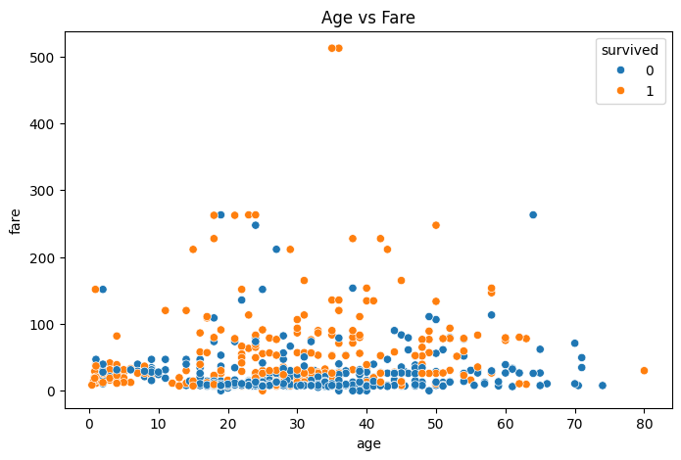

df["age"] = df["age"].fillna(df["age"].median())
df = sns.load_dataset("titanic")
df_clean = df.copy()

df_clean["age"] = df_clean["age"].fillna(df_clean["age"].median())

Conclusion:-

Exploratory Data Analysis was performed on the Titanic dataset to understand its structure, data quality, distributions, relationships, and important patterns. Missing values were identified and Age values were handled using the median. Different visualizations and correlation analysis were used to understand passenger survival patterns. The analysis shows that passenger class, gender, age, and fare are important variables for understanding survival patterns in the Titanic dataset. Overall, the EDA process helped identify meaningful patterns and prepared the dataset for further analysis.

